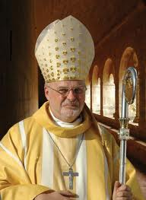

Anders Arborelius,ocd, Bishop Stockholms diocese.

Protector of the Living Rosary Apostolate.

Our Group

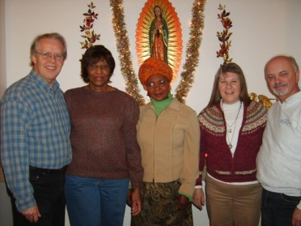

The founders of the Living Rosary Apostolate

Roger & Glenda La Fleur Olsson, (Sweden), Genevieve Mamai, (Kenya, Africa) Trudy & Frank Bonack, (WI, USA.)